

**FPGA Based Digital System Design**

**7067CEM**

**Coursework Submission**

Module Leader – **Amjad S. Khan**

**Prepared by:**

Samuel Iyiolade Osafehinti

SID - 14283716

[osafehints@uni.coventry.ac.uk](mailto:osafehints@uni.coventry.ac.uk)

Walid Bouzidi

SID - 14054035

[bouzidiw@uni.coventry.ac.uk](mailto:bouzidiw@uni.coventry.ac.uk)

Paras Mahajan

SID - 14324134

[mahajanp3@uni.coventry.ac.uk](mailto:mahajanp3@uni.coventry.ac.uk)

**March 30th, 2024**

**TABLE OF CONTENTS**

|  |  |
| --- | --- |
| 1. **Design Requirements** | **3** |
| 1. **Hardware Development** | **12** |
| 1. **Software Development** | **21** |
| 1. **Verification and Optimisation** | **31** |
| 1. **PCB Design** | **33** |
| 1. **References** | **38** |
| 1. **Appendix** | **39** |

# **HARDWARE REQUIREMENTS**

## **PROJECT DESIGN SPECIFICATIONS AND REQUIREMENTS**

The project requirement is the design of an FPGA based driver for an LED Dot-matrix Display.

## **PROVIDED HARDWARE**

The following are the hardware components provided to us to carry out the task of fulfilling the design requirements according to specifications.

**DIGILENT NEXYS A7 FPGA DEVELOPMENT BOARD**

The **FPGA** utilized is the **XILINX ARTIX-7** (XC7A100T-1CSG324C) made available on the Digilent NEXYS A7 development board. The development board is shown in the figure below.

**8x8 LED DOT-MATRIX COLUMN-ANODE DISPLAY**

The dot-matrix display provided is the 8x8 column-anode, 3mm RED LED dot-matrix display with part number **1088BS.**

A diagram of the internal connection structure of the LED matrix and a picture of the physical display is shown below.

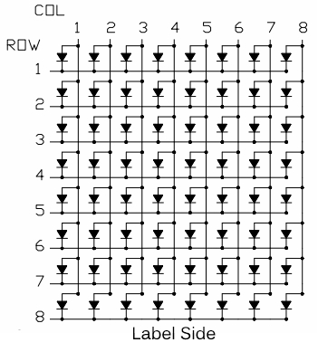

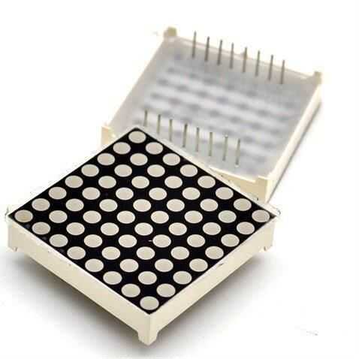

## **DESIGN APPROACH AND METHODOLOGY**

The design approach follows these two processes:

* Hardware Implementation
* VHDL logic implementation

Each of these processes is discussed below.

* + 1. **HARDWARE IMPLEMENTATION**

To properly implement a design based on any hardware, a detailed understanding of the hardware is necessary. The primary hardware component for this design is the LED Dot-Matrix display, therefore, the display physical layout and electrical characteristics must be properly understood to proceed.

**LED DOTMATIX-DISPLAY**

The dot-matrix display comprises an array of LEDs arranged in a matrix configuration of COLUMN and ROW intersections. This configuration is usually specified in their specification sheets as (COLUMN x ROW). For instance, a Dot-Matrix display with a five LED COLUMNs and a seven LED ROWs is specified as a (5x7) LED dot-matrix display in its specification sheet.

LEDs on the same row and column are linked together, therefore, each LED represents a unique connection of a and a COLUMN ROW.

Also, since each LED on the matrix has two terminals, anode, and cathode, there are two possible configurations of the LED matrix formation:

* Column-Anode Dot-matrix Display
* Column-Cathode Dot-matrix Display

Our provided dot-matrix display is the column-anode type as shown previously in Fig..

**DOT-MATRIX DISPLAY SCANNING**

Because the LEDs on a dot matrix display are arranged in an array form (each LED is a connection of a COLUMN and a ROW), the LEDs MUST be lit in a special way to display any character. This special lighting method (as concerned LED Dot-matrix Displays) is called **Display Scanning**. This involves lighting a specific LED or a specific group of LEDs on the matrix for a fraction of a second continually. Then, because of the **“persistence of vision”** phenomenon in the human eye, previously lit LEDs are still seen. The complete intended character is fully observed by the human viewer during the scan process.

For a typical LED dot matrix, one of the following three scanning methods can be used. The eventual scanning choice is a function of the length of the display, (if more are cascaded), intended brightness and flickering elimination.

These scanning methods are:

* Dot Scanning
* Horizontal Scanning
* Vertical Scanning

Each scanning method is illustrated below using the column-anode configuration.

**Dot Scanning**

**Horizontal Scanning**

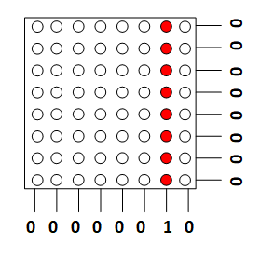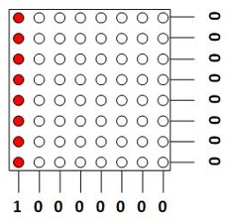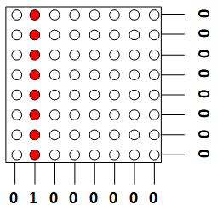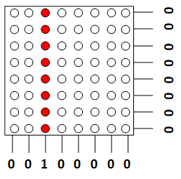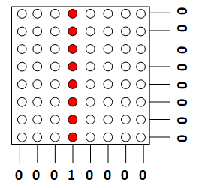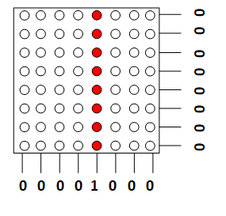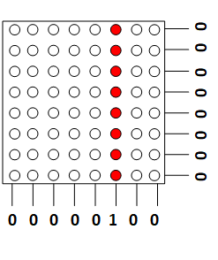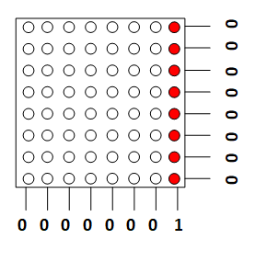

**Vertical Scanning**

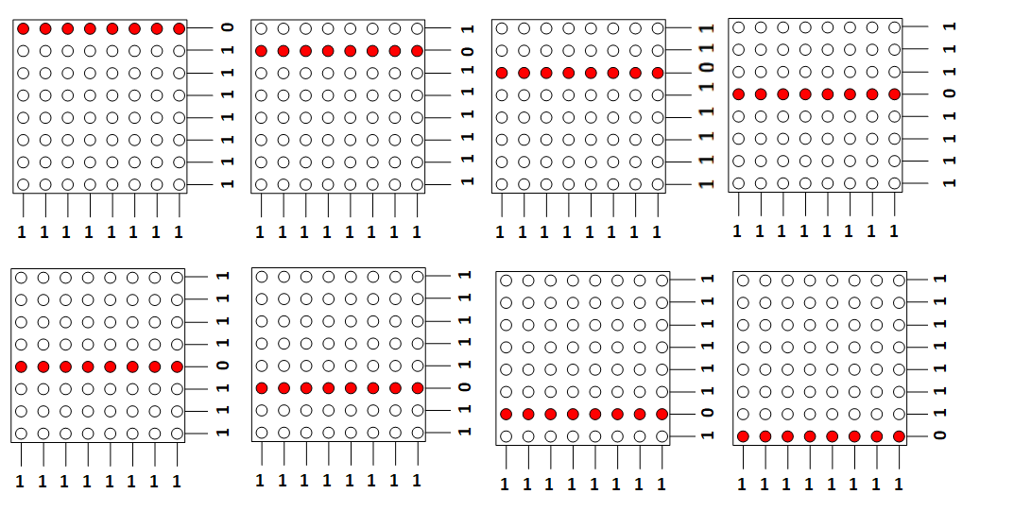

The choice of scanning method used is a function of the intended brightness and screen refresh speed and flicker elimination.

In most applications employing the use of the dot-matrix display, vertical scanning is used. Why?

In most use cases, multiple LED display-matrices are cascaded horizontally for longer character applications while the height vertically remains constant. Taking a cascading of four LED dot-matrices as an example would result in an effective matrix size of 32x8 (32 columns by 8 rows). Vertically, 32 columns need to be scanned but vertically, only 8 rows need to be scanned.

As an effective illustration, consider a display scan period of 16ms (a refresh rate of 62.5Hz) and an even distribution of this time among each scanned element. The table below shows the time allotted to each element of each display scanning method implemented on a **32x8 LED dot-matrix display**. The higher the time, the brighter the LED and vice versa.

From the table, it can easily be deduced that the vertical scan would produce better outcomes on the dot-matrix display.

Timing analysis of scanning methods

|  |  |  |  |
| --- | --- | --- | --- |
| **Scanning  method** | **Scan steps** | **On-time in 16 ms time frame** | **Entity** |
| Vertical (row by row) | 8 | 16 ms / 8 rows = 2 ms | All leds on a row |
| Horizontal (col by col) | 32 | 16 ms / 32 cols = 0.5 ms | All leds on a columns |
| Dot by dot | 256 | 16 ms / 256 dots = 0.0625 ms | Each led on the matrix |

**HARDWARE CONNECTIONS**

From the display scanning illustration in Fig.., opposite logic must be applied to the ROWS and the COLUMNS to light any LED on the matrix. Our LED matrix is the column-anode type; therefore, HIGH logic must be applied to the COLUMN and LOW logic must be applied to the ROWS to light any LED on a scanned ROW.

In this design case, the FPGA is to supply this logic. A typical connection to the FPGA demo-board is shown below:

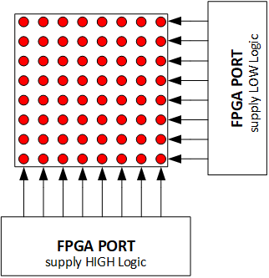

BUT…. there is an exception.. For adequate brightness, the dot-matrix will be powered from a +5V supply, but the maximum programmable voltage on the output of the FPGA is +3.3V. Therefore, adequate buffer drivers, usually Level Translators, MUST be placed between the FPGA output ports and the pins of the LED dot-matrix display. HIGH-logic output level translator is needed for the column connection while a LOW-logic output level translator is needed for the ROW connections.

In this design, the LSI digital chip **74HC245** is used as the HIGH-logic translator, while the **ULN2803** Darlington array chip is used as the LOW-logic translator.

With the inclusion of these **ICs**, the connection is modified as shown below:

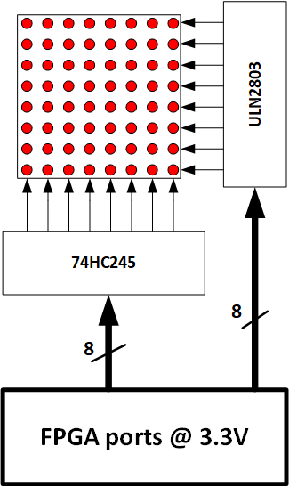

From the diagram above, the total number of ports needed from the FPGA to facilitate this connection is 8. Eventually, we decided to go further by cascading 4 led dot-matrix display units to accommodate a full moving text while also being able to display single alphanumeric characters.

A cascade of 4 dot-matrix displays would require 32 port pins from the FPGA for the COLUMN control and an additional 8 port pins for the ROW control as shown in the Fig.. below

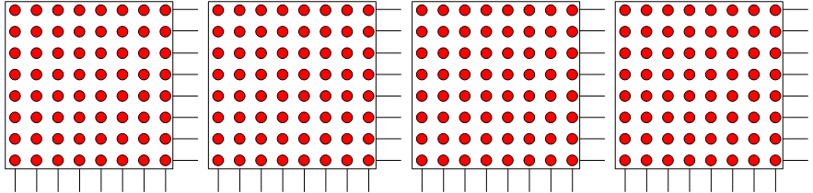

But the maximum digital port pins available from the Digilent FPGA demo-board is 32.

Therefore, an IO expansion MUST be performed on the FPGA port pins designated to control the COLUMNS of the dot-matrix display.

**IO EXPANSION**

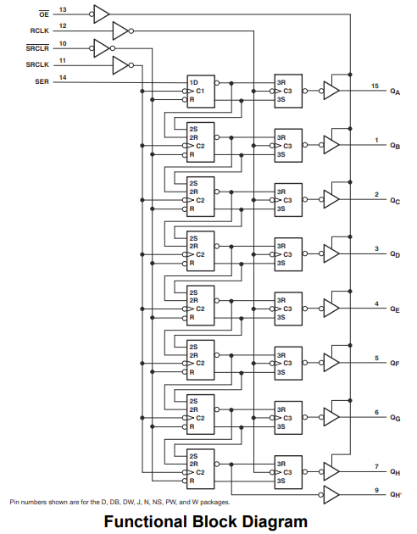The IO expansion was performed on the FPGA port pins using the **74HC595** LSI serial to parallel shift register chip. The **74HC595** is an 8-bit serial to parallel shift register. Multiple of these **ICs** can be daisy-chained to form a wider-bit serial to parallel shift register. In this case, 4 of these **ICs** cascade to form a 32-bit wide serial to parallel shift register. Below in FIG… is a functional diagram of the **74HC595** 8-bit serial to parallel shift register.



**COMPLETE CIRCUIT IMPLEMENTATION**

The final circuit implementation using the **74HC595** 8-bit serial to parallel shift register to expand the FPGA port pins is shown below in FIG…

* + 1. **LOGIC IMPLEMENTATION USING VHDL**

A detailed explanation of the logic implementation of the project design specifications using VHDL is given below. Our approach to the logic implementation using VHDL is clarified by itemizing each VHDL digital construct employed in the logic design.

Apart from the default project requirement, we went further to implement a moving text display using 4 LED dot-matrix modules, therefore, we implemented two architectures. To manage which architecture is running at any time, the two implemented architectures is instantiated from another VHDL file called the Top Entity. In the **TOP ENTITY**, selection between the two architectures is implemented through a multiplexer triggered by an external switch.

Below is in FIG… is a block diagram of the **TOP ENTITY** design and an **RTL view** of the same implementation.

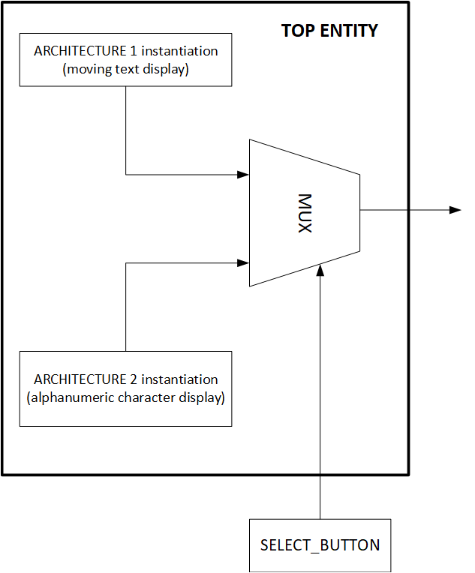

**TOP ENTITY VHDL DIGITAL CONSTRUCT BLOCKS**

Each VHDL block implementation in this TOP entity module as shown in FIG.. is described below.

* **MUX (multiplexer)**

The MUX block as shown in the block diagram is a simple 2-to-1 multiplexer. This is easily implemented in VHDL with a one-liner **when-else** statement and a process controlled by the signal assigned by the **when-else** statement. This is shown in the VHDL code snippet below in FIG…

* **ARCHITECTURE-1 (Moving Text Display)**

The ARCITECTURE-1 block is the complete **VHDL** implementation of the moving text display. The decomposition of this block to its constituent blocks is shown below in FIG…

Each composing block is described next.

**TextFile**

The text displayed on the dot-matrix module is hard coded into the VHDL file. This was implemented in the VHDL design by a simple array of characters (string).

The hard coded text is: ***“Welcome to 7067CEM: FPGA-Based Digital System Design “***

The code snippet where this is implemented in the VHDL file is shown below..

**Character ROM**

The character ROM (read only memory) holds the font pattern for each character to be displayed on the LED dot-matrix. This ROM is implemented as an array or arrays in the VHDL file. But first, how are these font patterns obtained?

A special dot-matrix font character generator software is used. The software used is the **GLCD** Font Creator software from **MikroElectronika.** The software allows the user to generate binary data from either existing system fonts or newly created fonts. In our case, most system fonts will not fit into an 8x8 matrix space, hence, designing our own fonts from scratch was necessary.

The GLCD Font Creator software easily facilitates this. Below in FIG.. is shown how binary data is obtained from font pattern on an LED-matrix display taking the alphanumeric character “A” as an example.

The binary data representing this font is obtained column-wise from left to right and from top (MSB) to bottom (LSB). The dark grey dots represent LEDs that are OFF (0) while the red dots represent LEDs that are ON (1). Therefore, for the first column, the binary data from top (MSB) to bottom (LSB) is “00000000”. For the second column, the binary data from top (MSB) to bottom (LSB) is “00111111”. Following the same encoding style, the binary data for the remaining columns are: “01001000”, “10001000”, “01001000”, “00111111”, “00000000”.

The complete binary data for character “A” in hexadecimal according to this font design is:

**A => (0x00, 0x3F, 0x48, 0x88, 0x48, 0x3F, 0x00)**

As can be observed, the font has a matrix dimension of **7x8** (7 COLUMNS x 8 ROWS).

This process was applied to all the printable characters of the **ascii** table to obtain the binary data of all the said characters. These were hard coded into the VHDL file in a ROM implemented as an array of arrays. There are 95 printable ascii characters from the **space character** (“ ”) to **Tilde** (“~”). Therefore, the ROM is implemented as an array of 95 elements with each element also an array of 7 byte-wide elements. The code snippet where this is implemented in the VHDL file is shown below..

**CLOCK DIV1 and CLOCK DIV2**

The CLOCK_DV1 and CLOCK_DV2 blocks are used to generate slower clock signals from the main clock source 100MHZ. These blocks are implemented as counters dividing the main clock source 100MHz to produce the needed frequencies. The code snippet where this is implemented in the VHDL file is shown below..

**HOLD REGISTER (scratchpad)**

The next block in this architecture is the HOLD register (scratchpad). This is a temporary storage area for the pre-fetched font binary data from the character ROM for the character to be displayed on the LED dot-matrix at a particular time. This hold-register is filled with the font data in the same way the character will look like on the physical display. Then each column of this register (starting from left to right) is selected and shifted to the SHIFT REGISTER ARRAY block. The code snippet where this is implemented in the VHDL file is shown below in FIG....

**SHIFT REGISTER ARRAY**

The shift register array is a size replica of the LED dot-matrix display area. The dot-matrix display area is 32x8 (32 COLUMNS x 8 ROWS) in size, therefore, the shift register array is also set up as a 32x8 register. Also, since this a moving text is to be displayed on the dot-matrix, this array is implemented as a shift register. This approach makes displaying and scanning anything on the dot-matrix display very easy. The code snippets where this array is implemented in the VHDL file is shown below in FIG....



**FSM1 and FSM2**

These blocks are **FINITE STATE MACHINES** used in sequencing (driving) the entire implementation. **FSM1** is the finite state machine that drives the process of scanning the internally implemented shift register array to the external dot-matrix display serially through the IO expansion circuit comprising the cascaded 74HC595 ICs.

On the other hand, **FSM2** state machine drives the process of left shifting the entire display area and appending a new column of data from the scratchpad area. This produces the moving text effect observed on the external dot-matrix display. Below in FIG… are the STATE TRANSITION DIAGRAMS of these Finite State Machines.

The code snippets where these Finite State Machines are implemented in the VHDL file is shown below in FIG....

* **ARCHITECTURE-2 (Alphanumeric Character Display)**

The ARCITECTURE-2 block is the complete **VHDL** implementation of the alphanumeric character display. The decomposition of this block to its constituent blocks is shown below in FIG…

The composing blocks are same ones previously described in architecture-1 with the exception of the **RERGISTER ARRAY** block.

**REGISTER ARRAY**

The register array is a size replica of the LED dot-matrix display area implemented as a STORAGE REGISTER ONLY and not a SHIFT REGISTER. This array is also 32x8 (32 COLUMNS x 8 ROWS) in size. The binary font data of the alphanumeric character to be displayed on the dot-matrix display is copied directly from the character ROM to the lower end of this array. CLOCK_DIV2 determines the frequency by which binary font data of new characters is copied to this register array. The finite state machine **FSM**, like finite state machine **FSM1** of the previous architecture, drives the process of scanning this register array to the external dot-matrix display serially through the IO expansion circuit comprising the cascaded 74HC595 ICs.

The code snippets showing the implementation of this Register Array in the VHDL file is shown below in FIG....

# **TEST BENCHES**

FPGA circuit design using VHDL follows a unique approach. For us, these are:

* Breaking down the circuit into smaller blocks to be implemented with VHDL.
* Verifying each block for proper functionality using test benches.
* When all blocks are fully verified, the blocks are connected to form the complete design unit. The complete design unit is then finally verified for expected functionality also using a testbench.

The test bench result of each block described in the previous chapter is the figures below:

**Main Clock**

**CLOCK_DIV1**

**CLOCK_DIV2**

**FSM/FSM1**

**\*Note1:** This is the state variable used in the FSM implementation to scan the dot-matrix Display. "SHOW0....SHOW7" are the states with the longest time duration of approx. 2 ms. These states represent when each respective row from top to bottom (0 to 7) of the matrix is lit for a fraction of a second in the vertical scanning implementation. The FSM control clock (SCAN_CLK) was adjusted from the test bench to precisely produce a 2ms period between each "SHOW" for a well-lit display.

**74HC595**

**\*Note2:** The 32-bit 74HC595 IO expansion was modelled in VHDL to verify the final circuit behaviour in actual operating mode.

**COMLETE CIRCUIT IMPLEMENTATION: ARCH-1**

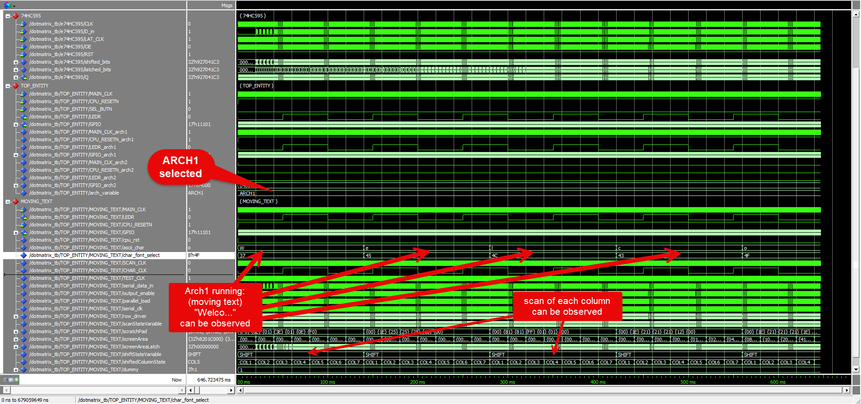

**ARCH1** selected and running. Part of the hard coded text ***(“Welco”)*** can be observed.

**COMLETE CIRCUIT IMPLEMENTATION: ARCH-2**

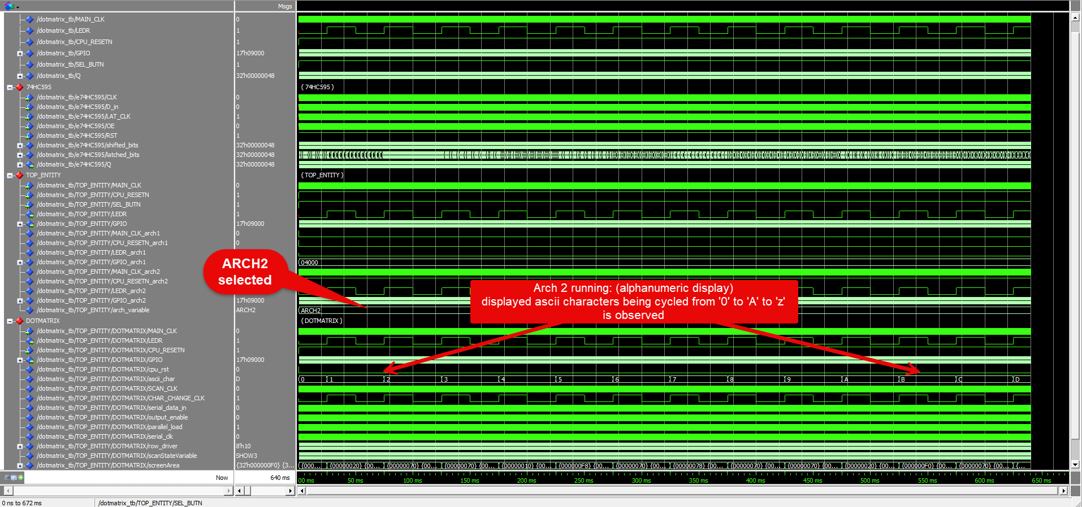

**ARCH2** selected and running. Ascii characters cycled from ‘0’ to ‘A’ to ‘z’ can be observed.

# **POWER ANALYSIS AND OPTIMIZATION**

***Please Note****: links to all design files have been provided in the appendix.*

# **REFERENCES**

**[1] – [3]** <https://www.analog.com/en/analog-dialogue/articles/all-about-direct-digital-synthesis.html>

**[4]** <https://www.microchip.com/en-us/product/PIC18F26K40>

**[5]** <https://www.microchip.com/en-us/product/mcp4921#document-table>

**[6]** <https://ftdichip.com/products/ft232rl/>

# **APPENDIX**

Below is the link to all design files pertaining to this project design: The link opens a folder in **one-drive** containing the following: *source-codes, schematics, PCB Layout design, Gerber File, BOM, 3D_output and a Demo-Video of the project in operation.*

[Embedded Hardware Engineering Project 7074CEM](https://livecoventryac-my.sharepoint.com/:f:/g/personal/osafehints_uni_coventry_ac_uk/EuT7ne8EHl1KhpBYzi6D6PcBlBwdzkJFr5KIJlO9YKHRcw?e=9haEJq)